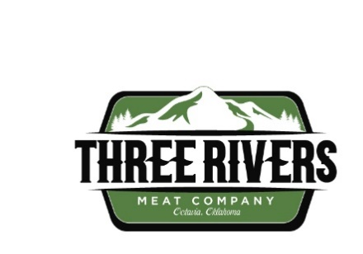
Three Rivers Meat Company Expands Focus on Smoked Meat Products
Expanding award-winning products
SMITHVILLE, Okla. (March 9, 2026) – Three Rivers Meat Company, located in Smithville, is expanding its line of processed meats and value-added products. Since its opening in 2024, Three Rivers Meat Company has crafted a variety of specialty offerings—including smoked meats, hot links, and beef jerky—that have earned multiple industry awards and become popular among customers.
“The popularity and demand for our processed meat products are allowing us to shift our business model to meet the demand. We currently offer meat sticks and beef jerky at the Choctaw Tribal Plazas and Roots Café and are exploring additional commercial avenues for these shelf-stable products,” said Evan Whitley, PhD, chief operating executive of Three Rivers Meat Company and executive director of Agriculture and Natural Resources for the Choctaw Nation of Oklahoma.
The demand for Three Rivers' high-quality, locally smoked meats, including turkey, bone-in ham, chicken fried steak, bologna, and summer sausage, has also increased. Three Rivers will convert a portion of its butchering space for processed meats and will no longer provide outside beef butchering service.
Three Rivers meat processing products have won numerous awards since their inception in 2024, including 11 gold medals from the German Butchers Association (DFV, short for Deutschmark Fleischer-Verband) and the American Association of Meat Processors competition at Iowa State University. The competition is held every three years, and the gold medal is the most difficult and coveted award in processed meat competitions worldwide.
Most recently, Three Rivers competed against more than 194 meat processors for the 2025 Oklahoma/Texas Association of Meat Processors Awards, bringing home three awards, including:
- Champion – Bone-in Hams
- Champion – Smoked Turkey
- Grand Champion – Smoked Hot Links

Three Rivers Meat Company has a retail store with freezer and cold sections, as well as fresh produce. Three Rivers Cafe has a meat and deli counter with fresh cuts of meat, deli meats, house-made cheese, and precooked items. They also sell in-house value-added products, such as sausage, bacon, and chicken-fried steak. The retail area is currently open from 7 a.m. to 6 p.m. Monday through Saturday and accepts SNAP and EBT benefits.
###

